**Measuring Earth's Magnetic Field Strength with Helmholz Coils**

Up until the 1830s it was difficult to measure the magnetic field of the Earth quantitatively because there were no real standard to compare it against. As electromagnetic theory was developed through the 1800s it was found that magnetic field strengths could be given absolute values by the use of a coil carrying an electrical current. In this investigation you are tasked with the job to measure the local magnetic field by comparing it to a know value created by a coil of known size, current, and turns.

If you place a compass on a bench and let it point north, you can make it move towards the east or west by placing a magnetic field at right angles to the compass direction. If you can get the needle to move to 45° it means that the coil's field is the same magnitude as the Earth's field - but just acting at right angles.

You can use the Biot-Savart Law to determine magnetic field strength due to the coil: BC = 8 μoNI/(R x 5√5) where N = number of turns on each coil (not the total), I is the current, R is the radius of the coil. The constant μo is the permeability of free space (4πx10-7Tm/A).

You must research and develop a method and apparatus to measure the local magnetic field strength of the Earth at Rockingham and compare this to the documented Earths magnetic field strength at this location.

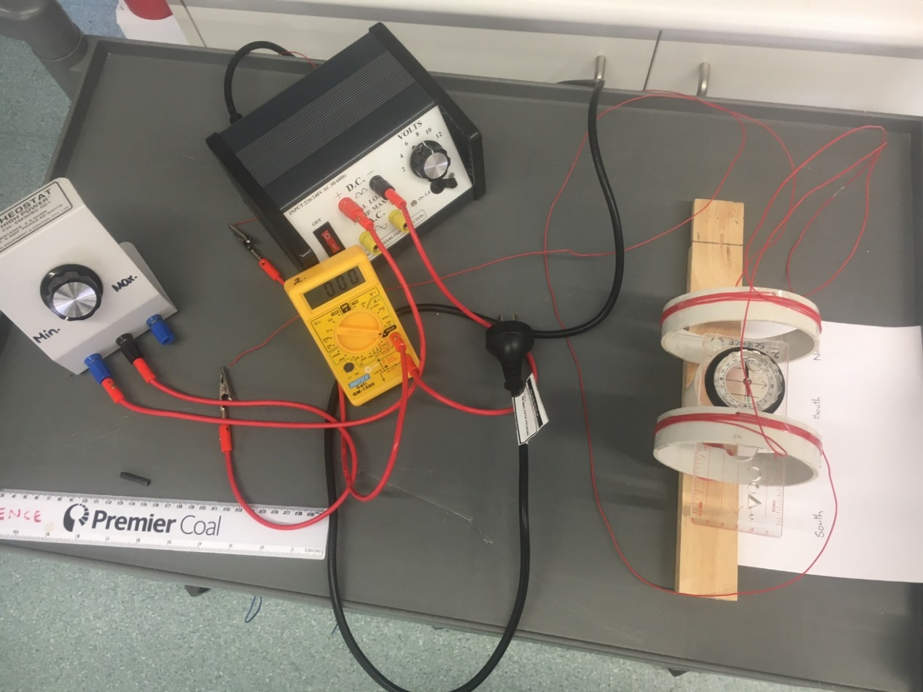

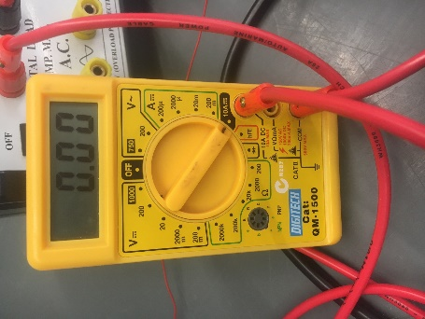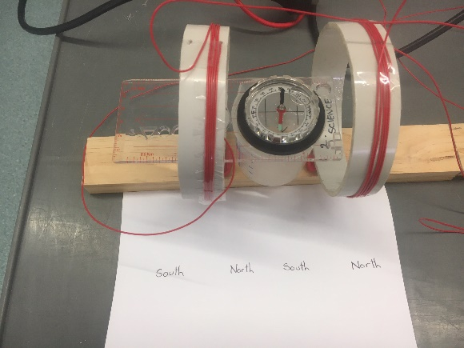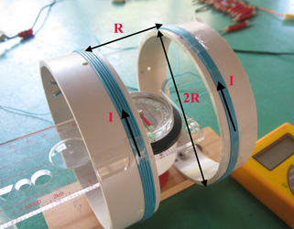

At each angular position, the net torque T (tau) on the magnetic compass needle must be zero, if the needle is stationary. Therefore, the torque ΤH due to the horizontal component of Earth's magnetic field and the torque ΤC due to the coil's magnetic field on the needle must be equal and opposite:

TC= TH  
   
μoBCcosΦ = μoBHsinΦ   
  
BC = BHtanΦ

Where BC is the horizontal field from the coil and BH is the horizontal field from the Earth. The relationship takes the form y = mx + c.

The value of the Earths horizontal magnetic field strength at Rockingham can be verified from the government geomagnetic data website at

<http://www.ga.gov.au/scientific-topics/positioning-navigation/geomagnetism/basics/earths-magnetic-field>

through the specific link to Australia Geomagnetic Reference Field Values at:

<https://geomagnetism.ga.gov.au/agrf-calculations/agrf-form>

Please analyse these two web pages and verify that the horizontal component of the Earths magnetic field is 23520nT at Rockingham. ( 32.2781° S, 115.7351° E)

Collect appropriate data using the equipment provided and conduct an investigation to verify this value. Submit your report by _______________________

Marking key for Investigations

Student Name:-______________________________________________

|  |  |
| --- | --- |
| **Description** | **Marks** |
| **Phase 1 – Planning** | **/9** |
| Develops a clear hypothesis which relates the variables Lists all materials required  States how controlled variables were controlled Plans for repeat trials | 1–2  1–3  1–2  1–2 |
| **Phase 2 – Conducting** | **/15** |
| Clearly lists the procedure/method to be used  Shows a labelled diagram or photograph of equipment set-up Selects appropriate equipment and collects accurate results Displays data in suitable table  Displays data in suitably labelled and presented graph | 1–5  1–2  1–2  1–2  1–4 |
| **Phase 3 – Processing** | **/10** |
| Averages data from repeat trials  Calculates/Processes relevant Quantities correctly where appropriate Makes a valid statement about trends in the data  States a conclusion and relates it to the hypothesis | 1–2  1–4  1–2  1–2 |
| **Phase 4 – Evaluation** | **/6** |
| Discusses sources of uncertainty in the data  Makes reasonable suggestions for improvements to procedure Uses appropriate scientific terminology in the discussion | 1–2  1–2  1–2 |
| **Total** | **/40** |